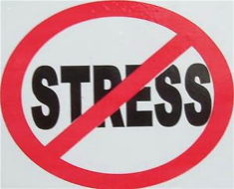
Stressed out with exams or life in general?
Basically…
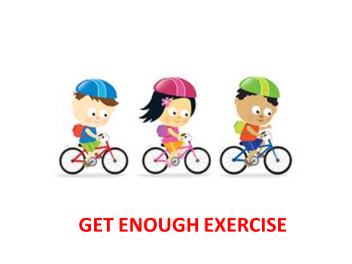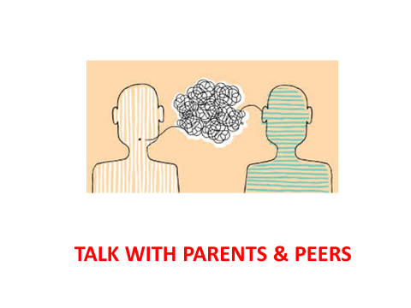

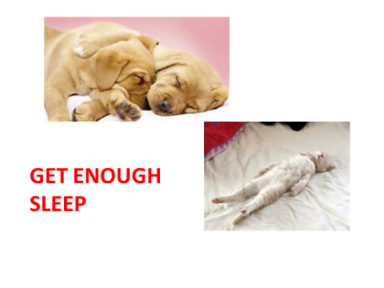
Obviously we have our own pastoral team in school to help you, but here are some additional websites that might help!
- ‎Anxiety UK
- Childline
- Student Minds
- Youngminds
How to help your child beat exam stress:
- NHS
- See our guidance on how to assist your child with planning and doing revision.
It is important to remember that feeling anxious is a very normal experience especially in the run up to exams, and it may even help your performance! The NHS describes anxiety as a feeling of unease, such as worry or fear, that can be mild or severe.
Everyone has feelings of anxiety at some point in their life. For example, you may feel worried and anxious about sitting an exam or competing in a sports event. During times like these, feeling anxious can be perfectly normal. However, some people find it hard to control their worries. Their feelings of anxiety are more constant and can often affect their daily life.

Research shows that ANXIETY is by far the most common psychological disorder experienced by school-aged children so here are some tips for pupils and parents to deal with it.
- Exercise and fresh air can have massive benefits in calming you down. Exercise releases serotonin in your brain, a mood regulating neurotransmitter , which will make you feel better, and has been shown to be as effective as anti-anxiety and anti-depressant tablets in regulating mood. (Recchia et al. 2022)
- Sharing is better than holding back – TALK about your anxiety and it’s triggers.
- Stress coping tools are not always physical activities, there are ways to help yourself get over a specific stressful event faster without engaging in anything that creates more stress, such as self-talk.
- Healthy distractions such as listening to music, talking to friends or completing a puzzle or game can be a huge help.
- Make stresses fun wherever possible. Turn your tasks into competitions for yourself. Plan activities to look forward to once your stressful moment is over.
- Write out unforgettable thoughts. Writing a diary or jotting down worries you may have at night are proven stress relief methods that help you put your fear into perspective.
- Drink plenty of water as prevents dehydration which relaxes the brain.
- Do NOT google your symptoms.
- Surround yourself with positive, influential people.
- Don’t forget that your anxiety is not silly. It matters and it can be overcome. You can beat it.
Top Tips for Anxiety Sufferers:

Here’s some self-talk tips to deal with anxiety:

When Anxiety is Near
1. I’m going to be all right. My feelings are not always rational. I’m just going to relax, calm down, and everything will be all right.
2. Anxiety is not dangerous -- it’s just uncomfortable. I am fine; I’ll just continue with what I’m doing or find something more active to do.
3. Right now I have some feelings I don’t like. They are really just phantoms, however, because they are disappearing. I will be fine.
4. Right now I have feelings I don’t like. They will be over with soon and I’ll be fine. For now, I am going to focus on doing something else around me like:
5 things I can see.
4 things I can touch.
3 things I can hear.
2 things I can smell.
1 thing I can taste.
5. That worry in my head is not a healthy or rational worry. Instead, I’m going to focus on something positive like _________________________.
6. I’ve stopped my negative thoughts before and I’m going to do it again now. I am becoming better and better at deflecting these automatic negative thoughts (ANTs) and that makes me happy.
7. So I feel a little anxiety now, SO WHAT? It’s not like it’s the first time. I am going to take some deep breaths and keep on going. Breathe in for the count of 7 and out for 11. This will help me continue to get better.

Statements to use when preparing for a stressful situation
1. I’ve done this before so I know I can do it again.
2. When this is over, I’ll be glad that I did it.
3. The feeling I have about this event doesn’t make much sense. This anxiety is like a mirage in the desert. I’ll just continue to "walk" forward until I pass right through it.
4. This may seem hard now, but it will become easier and easier over time.
6. Experiencing a little anxiety in this situation will help me perform at my best.

Statements to use when I feel overwhelmed
1. I can be anxious and still focus on the task at hand. As I focus on the task, my anxiety will go down.
2. Anxiety is an old habit pattern that my body responds to. I am going to calmly change this old habit. I will ground myself using 5-4-3-2-1 thinking (explained above) then anxiety and panic will shrink.
3. At first, my anxiety was powerful and scary, but as time goes by it doesn’t have the hold on me that I once thought it had. I am moving forward all the time.
4. I don’t need to fight my feelings. I realise that these feelings won’t stay around very much longer. I just accept my new feelings of peace, contentment and confidence.
5. All these things that are happening to me seem overwhelming. But I’ve caught myself this time and I refuse to focus on these things. Instead, I’m going to talk slowly to myself, focus on things I have control over and continue with what I have to do. In this way, my anxiety will have to shrink away and disappear.

How to help as a parent:
- Communicate: it is important to talk to your child about their anxieties and worries and validate their feelings.
- Understanding: it may help to explain what anxiety is and the physical effects it has on our bodies, and that it is like a wave that builds up and will then ebb away again.
- Preparation: if you know a change is coming up prepare the child by talking to them about what is going to happen and why.
- Practical: engage in problem solving rather than avoidance, i.e. consider the environment, distraction techniques and coping skills, school counselling.
- Containment: try not to become anxious yourself.
- Seek support: pastoral care team in school, your GP who may make a referral to CAMHS if symptoms persist or are very severe.

Hope this helps!

Recchia F, Leung CK, Chin EC, et al
Comparative effectiveness of exercise, antidepressants and their combination in treating non-severe depression: a systematic review and network meta-analysis of randomised controlled trials
British Journal of Sports Medicine 2022;56:1375-1380.

